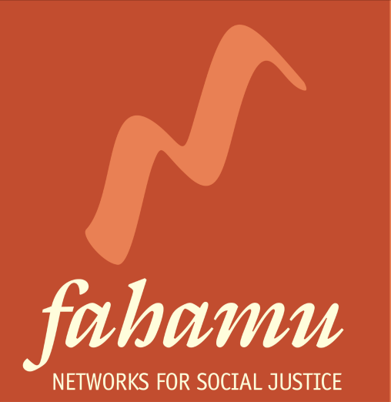

CALL FOR CONSULTANT RESOURCE PERSONS FOR THE

SEX WORKERS LEADERSHIP INITIATIVE (SWLI)

- INTRODUCTION

Fahamu is establishing a sex worker leadership initiative (SWLI) for sex worker rights activists based in Eastern and Southern Africa. The outcome of the proposed SWLI will be a strengthened sex worker movement in Eastern and Southern Africa able to translate their desired impact into concrete action plans, within which they are able to articulate theories of change, identify and engage allies as well as implement effective, innovative strategies using a diversity of tools.

Based on in-depth learning needs assessment with participants, the sex worker rights movement and global sex worker rights initiatives, we have developed a training curriculum dubbed The Pow Wow that will guide the SWLI process in each country.

It is for this Initiative that Fahamu is looking for 2 passionate and committed resource persons to deliver the training content based on the Pow Wow curriculum to sex worker activists in each of the five following countries: Kenya, Uganda, Tanzania, Zimbabwe and Namibia.

- SPECIFIC TASKS AND DELIVERABLES

The Resource Persons will be expected to:
- Deliver the content of the Pow Wow over a 12-week period
- Design an appropriate process and methodology for the workshops in line with Pow Wow objectives and principles.
- Mentor and support participants to strengthen networks, support individual growth and build a learning and solidarity community.
- Collaboratively develop the Pow Wow gathering agenda with host organization, participants, and counselor.
- Advise the host organization and Fahamu on preparation of reading materials to be used in the training and logistics that relate to Pow Wow delivery (e.g. style of room needed, outdoor facilities to be used, equipment needs).
- Document the Pow Wow
- Collect monitoring and evaluation data.

All ten-resource persons will be required to attend a five-day resource person’s induction in January 2013 which will serve as a training of trainers and induction into the Pow Wow process.

    - Specific Outputs:

By the end of the contract the resource persons will be required to deliver the following outputs.

- Tailored curriculum and proposed facilitation guide
- Documentation of each Pow Wow Gathering held
- Weekly reports to Fahamu on Pow Wow Gatherings
- Monitoring and evaluation report

- SKILLS REQUIRED:

The Resource Person should have:
- Experience in delivering of content and use of diverse methodologies in adult learning, especially with sex workers and sex worker rights activists.
- Experience and demonstrated commitment to the principles of social justice
- Excellent oral and written communication skills in English
- Fluency in the most spoken or common African language in the country of work (e.g. Kiswahili in Tanzania, Baganda in Uganda)
- Experience working with marginalized communities including LGBTI persons and sex workers
- Excellent feminist facilitation skills including a sex positive approach
- Experience in understanding movement building in Africa
- Knowledge and experience of the sex work industry, sex worker organizing and advocacy issues in Africa
- Knowledge and experience of sexuality training, sexual rights and health approaches and the ability to train others
- A willingness to learn and work in non-hierarchical processes
- Ability to work and deliver to tight deadline

- CONSULTANCY PERIOD

The consultancy will be conducted over a period of 12 weeks between, January 2013 –July 2014 depending on the country. A clear time frame will be discussed with the resource persons upon selection.

- SUBMISSION OF APPLICATIONS

Interested candidates should send a resume with contact details and the name of two referees along with a letter of interest which details your experience working with sex worker communities and activists, your reason for wanting to be part of this initiative and the pedagogical approach you would bring to this process.

Please send these materials to infokenya@fahamu.org by Monday 10th April 2013. And include POW WOW Resource Person in the subject heading.

Only short listed applicants will be contacted.

