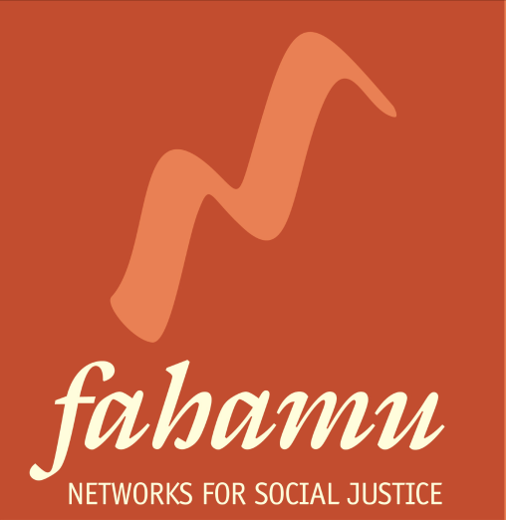

CALL FOR APPLICATIONS

CONSULTANT SELECTION PANELIST FOR THE SEX WORKERS LEADERSHIP INITIATIVE (SWLI)

1. INTRODUCTION

Fahamu is establishing a sex worker leadership initiative (SWLI) for sex worker rights activists based in Eastern and Southern Africa. The outcome of the proposed SWLI will be a strengthened sex worker movement in Eastern and Southern Africa able to translate their desired impact into concrete action plans, within which they are able to articulate theories of change, identify and engage allies as well as implement effective, innovative strategies using a diversity of tools.
Based on an in-depth learning needs assessment with participants, the sex worker rights movement and global sex worker rights initiatives, we have developed a training curriculum dubbed The Pow Wow that will guide the SWLI process in each country.
It is for this initiative that Fahamu is looking for three (3) passionate and committed sex workers’ activists who will join a team of resource persons and Fahamu in selecting other sex workers to participate in the Pow Wow training in each of the following five countries: Kenya, Uganda, Tanzania, Zimbabwe and Namibia.

2. SPECIFIC TASKS

The representatives will be expected to:

- Review applications from sex workers in their country
- Conduct 1 on 1 interviews with the shortlisted participants
- Recommend the selected participants to take part in the SWLI

3. REQUIREMENTS

The representative on the selection panel should have:

- A sex worker or passionate and committed to seeing sex workers develop their leadership skills
- Knowledgeable and experienced about sex work industry and sex workers’ organizing issues across the country
- Must be based in either of the 5 countries of SWLI implementation
- Excellent oral and written communication skills in English
- Fluency in the most spoken or common African language in the country of work (e.g. Swahili in Tanzania, Baganda in Uganda)
- Knowledge and experience of the Sex work industry, organizing and issues across the country.
- Ability to demonstrate transparency and accountability.
- Willing to work on voluntary basis

4. TIME OF PERFORMANCE

The Selection panel will work over a period of 1 month from 10th April-10th May 2013. This task is Voluntary.

5. SUBMISSION OF APPLICATIONS

If you are interested kindly send your C.V. and an expression of Interest letter titled SWLI PANEL explaining why they would like to be part of this panel (not more 300 words) to infokenya@fahamu.org by 10th April 2013.

Only successful candidates will be contacted!

